Experiment 3
Aim: Create a simple cloud software application for Hospital appointment booking using any Cloud Service Provider to demonstrate SaaS.
Procedure
1. Open Zoho creator app
2. Loin the zoho app
3. On top right click on the new application
4. after clicking the new application click on the building From scratch
5. Then give the application name Hotel management booking after giving the name click Ok button
6. Go to Forms and select Hotel management booking.
7. Click on it changes what ever field names you want and done.
8. Now go to Hotel management booking Form and fill Your details.
OUTPUT
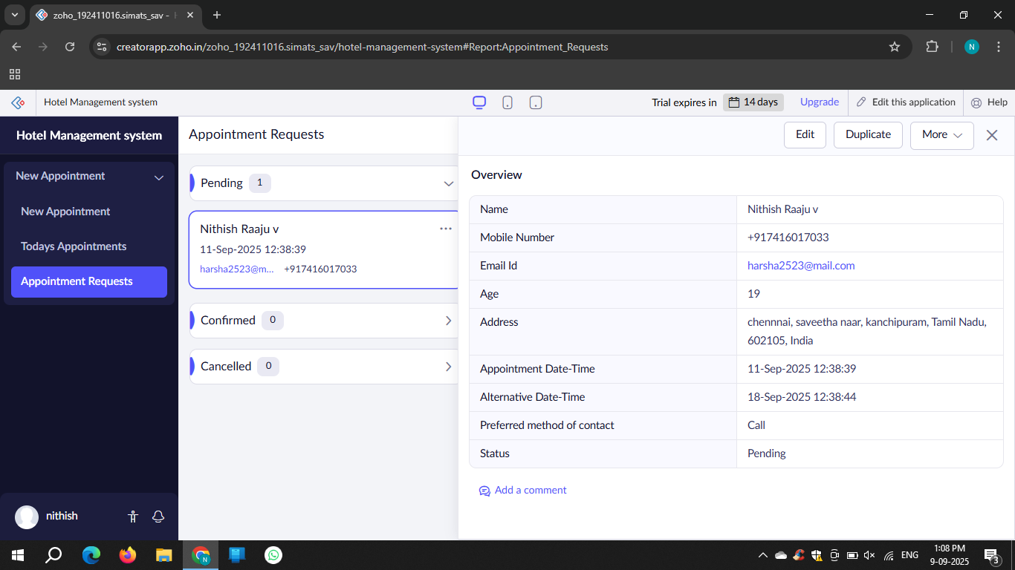
Result: The experiment was executed successfully

